***Dt : 26/10/2022***

***\*imp***

***Method References in Java:(Java8 - new feature)***

***=>The process in which abstract method of functional Interface is attached***

***with the method_body of a class,where the class is not related to interface***

***is known as "Method references Concept".***

***=>Method references are categorized into three types:***

***(a)Reference to Constructor***

***(b)Reference to Instance method***

***(c)Reference to Static method***

***(a)Reference to Constructor:***

***=>The process in which abstract method of functional interface is***

***attached with the Constructor_body is known as "Reference to Constructor".***

***syntax:***

***Func_Interface ob = Class_name :: new;***

***Ex:***

***ITest ob1 = Display :: new;***

***(b)Reference to Instance method:***

***=>The process in which abstract method of functional interface is***

***attached with the Instance_method_body is known as "Reference to Instance***

***Method".***

***syntax:***

***Func_Interface ob = Object_name :: Instance_method_name;***

***Ex:***

***ITest ob2 = d :: dis1;***

***(c)Reference to Static method:***

***=>The process in which abstract method of functional interface is***

***attached with the Static_method_body is known as "Reference to Static***

***Method".***

***syntax:***

***Func_Interface_name ob = Class_name :: static_method_name;***

***Ex:***

***ITest ob3 = Display :: dis2;***

***Ex-program:***

***ITest.java***

***package test;***

***public interface ITest {***

***public abstract void m(int k);***

***}***

***Display.java***

***package test;***

***public class Display {***

***public Display(int x) {***

***System.out.println("====Constructor body=====");***

***System.out.println("The value x:"+x);***

***}***

***public void dis1(int y) {***

***System.out.println("====Instance method body=====");***

***System.out.println("The value y:"+y);***

***}***

***public static void dis2(int z) {***

***System.out.println("====Static method body=====");***

***System.out.println("The value z:"+z);***

***}***

***}***

***DemoMethodReferences.java(MainClass)***

***package maccess;***

***import test.*;***

***public class DemoMethodReferences {***

***public static void main(String[] args) {***

***ITest ob1 = Display :: new; //Reference to Constructor***

***ob1.m(121);//Con_body_executed***

***Display d = new Display(100);//Con_call***

***ITest ob2 = d :: dis1;//Reference to Instance method***

***ob2.m(122);//Instance_method_body_executed***

***ITest ob3 = Display :: dis2;//Reference to Static method***

***ob3.m(123);//Static_method_body_executed***

***}***

***}***

***o/p:***

***====Constructor body=====***

***The value x:121***

***====Constructor body=====***

***The value x:100***

***====Instance method body=====***

***The value y:122***

***====Static method body=====***

***The value z:123***

***Diagram:***

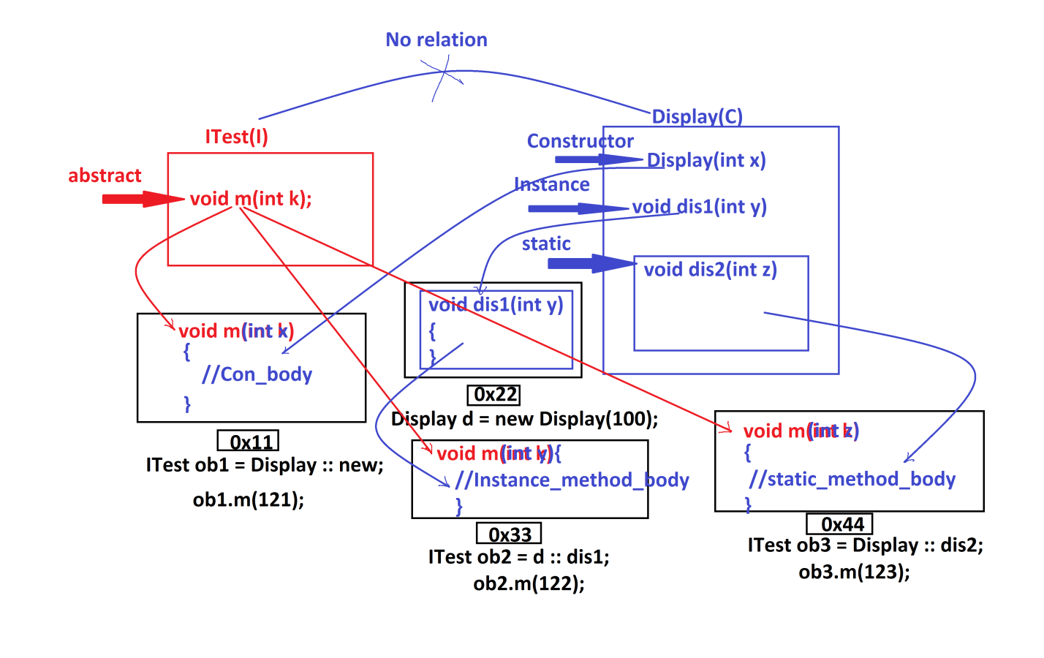

***=============================================================***

***\*imp***

***InnerClasses in Interfaces:***

***=>we can also declare InnerClasses in Interfaces and which are***

***automatically static member InnerClasses.***

***\*imp***

***InnerClasses in AbstractClasses:***

***=>we can also declare InnerClasses in AbstractClasses and which can be***

***Static member InnerClasses or NonStatic member InnerClasses.***

***Ex:***

***ITest.java***

***package test;***

***public interface ITest {***

***public static class SubClass2{***

***public void m2(int x) {***

***System.out.println("****Interface InnerClass m2(x)****");***

***System.out.println("The value x:"+x);***

***}***

***}//Static member InnerClass***

***}//OuterInterface***

***AClass.java***

***package test;***

***public abstract class AClass {***

***public class SubClass3{***

***public void m3(int y) {***

***System.out.println("****AClass Instance InnerClass m3(y)****");***

***System.out.println("The value y:"+y);***

***}***

***}//Instance member InnerClass***

***public static class SubClass33{***

***public void m33(int z) {***

***System.out.println("****AClass Static InnerClass m33(y)****");***

***System.out.println("The value z:"+z);***

***}***

***}//Static member InnerClass***

***}//OuterAbstractClass***

***DemoInnerClasses4.java(MainClass)***

***package maccess;***

***import test.*;***

***public class DemoInnerClasses4 {***

***public static void main(String[] args) {***

***ITest.SubClass2 ob2 = new ITest.SubClass2();***

***ob2.m2(111);***

***AClass ob = new AClass()***

***{***

***//Anonymous_Class_body***

***};***

***AClass.SubClass3 ob3 = ob.new SubClass3();***

***ob3.m3(222);***

***AClass.SubClass33 ob33 = new AClass.SubClass33();***

***ob33.m33(333);***

***}***

***}***

***o/p:***

***\*\*\*\*Interface InnerClass m2(x)\*\*\*\****

***The value x:111***

***\*\*\*\*AClass Instance InnerClass m3(y)\*\*\*\****

***The value y:222***

***\*\*\*\*AClass Static InnerClass m33(y)\*\*\*\****

***The value z:333***

***================================================================***

